**Reporting of Total Equipment and Mount Weights:**

To capture the total equipment and mount weights, the following procedures will be used to calculate the weights. The total equipment and mount weight will then be included in the mount analysis report.

**Total Equipment Weight:**

The total equipment weight will be calculated by summing of all the weights of the discrete appurtenances in the final loading configuration and adding an additional 100 lbs to account for the weight of ancillary equipment on the mounts such as coax, jumpers, grounding, etc.

**Total Mount Weight:**

The total mount weight will be calculated by taking the total weight of the unmodified structure from the RISA model (not including equipment weights or structural modifications) and applying a mount weight factor determined based on the applicable mount type from the table below. The mount weight factors below will account for the additional weight of structural materials and components not commonly modeled in RISA such as collar mounts, crossovers, connection hardware, etc.

|  |  |
| --- | --- |
| **Mount Type** | **Mount Weight Factor** |
| Sector Frames (Round) | 1.9 |
| Sector Frames (Flat) | 1.4 |
| Low Profile Platform | 1.4 |
| Platform w/ Support Rails | 1.5 |
| Platform w/ Support Rails & Kickers | 1.6 |
| Single-Sector T-Arm | 2.4 |
| Three-Sector T-Arms | 1.8 |

For reporting the weight of a mount with proposed structural mods (as in the post-mod analysis report), the total mount weight will be calculated by adding the weight of the proposed modification materials to the weight of the unmodified mount.

**Mount Type Example Images**

Sector Frame (Round):

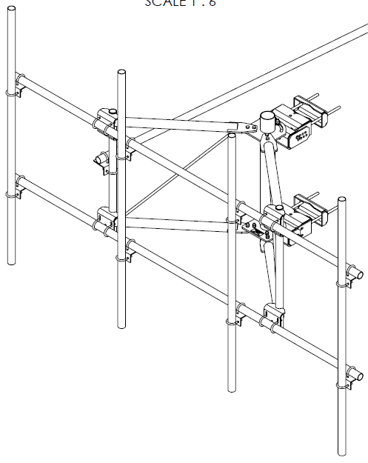

Sector Frame (Flat):

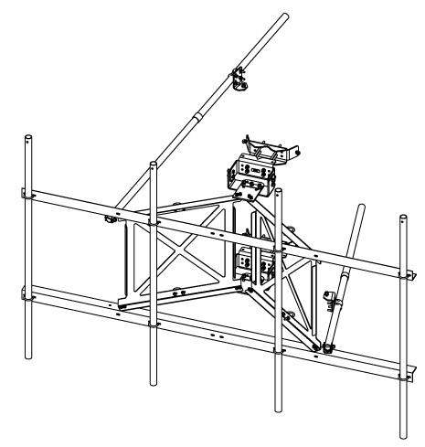

Low Profile Platform:

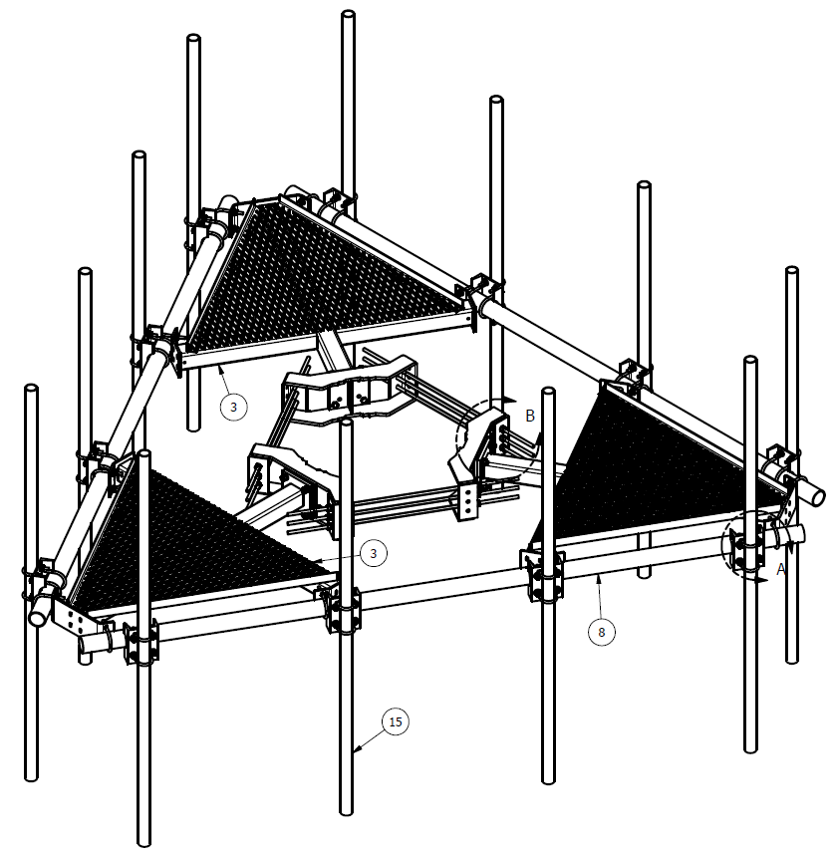

Platform w/ Support Rails:

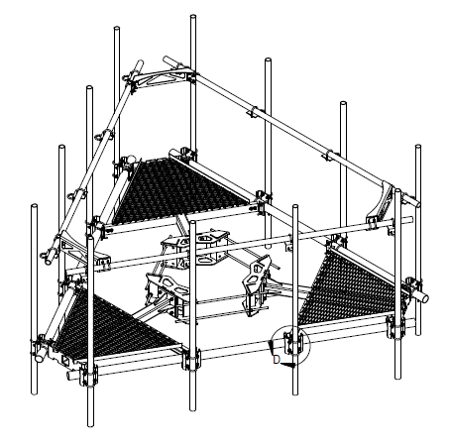

Platform w/ Support Rails & Kickers:

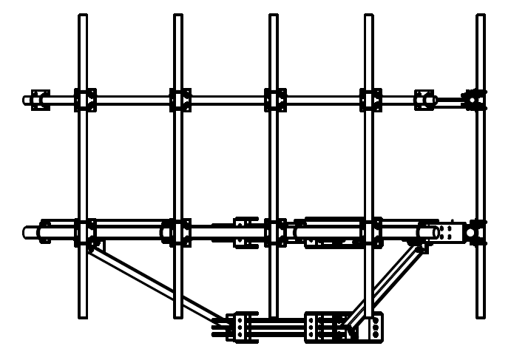

Single-Sector T-Arm:

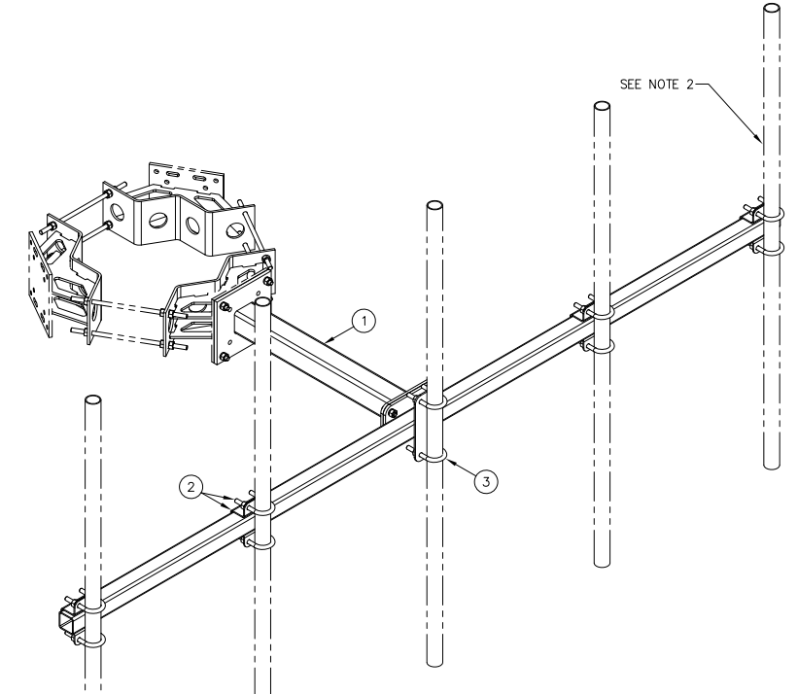

Three-Sector T-Arm:

